

EMERGENCY ROOM PRIORITY HANDLING SYSTEM USING HEAPS

A CAPSTONE PROJECT REPORT

A Capstone Project Report submitted in partial fulfilment of the requirements for the Course of

CSA0315 – DATA STRUCTURES

to the award of the degree of

BACHELOR OF ENGINEERING / BACHELOR OF TECHNOLOGY IN
ARTIFICIAL INTELLIGENCE AND DATA SCIENCE

Submitted by
Nandha Krishna V (192524012)
Hoshea Paul D (192471019)

Under the Supervision of Guide Name
SIMATS ENGINEERING
Saveetha Institute of Medical and Technical Sciences Chennai-602105

SEPTEMBER 2026

SIMATS ENGINEERING
Saveetha Institute of Medical and Technical Sciences Chennai-602105

BONAFIDE CERTIFICATE

This is to certify that the Capstone Project entitled “EMERGENCY ROOM PRIORITY HANDLING SYSTEM USING HEAPS” has been carried out by Nandha Krishna V (192524012) and Hoshea Paul D (192471019) under the supervision of Dr. T. Rajesh Kumar and is submitted in partial fulfilment of the requirements for the current semester of the B.Tech Artificial Intelligence and Data Science and B.Tech CS & BIO SCI program at Saveetha Institute of Medical and Technical Sciences, Chennai.

COURSE COORDINATOR COURSE FACULTY
Dr. Kiruthika S, Dr. T. Rajesh Kumar,
Professor Professor
CSE/Machine Learning Department of Deep Leaning
SIMATS Engineering, SIMATS Engineering,
SIMATS, Chennai – 602105. SIMATS, Chennai – 602105.

SIMATS ENGINEERING
Saveetha Institute of Medical and Technical Sciences Chennai-602105

DECLARATION

We, Nandha Krishna V of AI & DS and D . Hoshea Paul of CS & BIO SCI , SIMATS Engineering, Saveetha Institute of Medical and Technical Sciences, Chennai, hereby declare that the Capstone Project Work entitled “EMERGENCY ROOM PRIORITY HANDLING SYSTEM USING HEAPS” is the result of our own bonafide efforts. To the best of our knowledge, the work presented herein is original, accurate, and has been carried out in accordance with the principles of engineering ethics and academic integrity. All sources, references, data, and other materials used in the project have been appropriately acknowledged. We further declare that the data, results, analysis, and findings presented in this report have not been fabricated, falsified, or manipulated. Any external tools, software, datasets, computational resources, or AI-assisted tools used during the project have been appropriately disclosed. We confirm that all applicable ethical, academic, institutional, and professional requirements have been duly followed throughout the planning, execution, analysis, and documentation of the project.

Place:
Date:

Signature of the Students with Names

Nandha Krishna V(192524012)
D Hoshea Paul (192471019)

SIMATS ENGINEERING
Saveetha Institute of Medical and Technical Sciences Chennai-602105

Individual Contribution Statement

Student Name / Register No. | Specific  Responsibilities | Design & Development Contribution | Testing & Analysis  Contribution | Report Contribution | Approx.  Contribution (%)
Hoshea Paul D (192471019) | System design, patient registration, emergency priority assignment, Max Heap implementation and priority scheduling | Designed and implemented the Max Heap-based priority scheduling system and patient registration | Tested heap insertion, deletion, heapify operations, priority ordering, and emergency-level scheduling | Contributed to Introduction, Problem Statement, Objectives, Methodology, System Architecture, Heap Implementation and Results | 50%
Nandha Krishna V (192524012) | Patient lookup, Hash Table implementation, treatment management, statistics, reporting and program integration | Implemented Hash Table lookup, treatment features, statistics and menu integration | Tested patient lookup, collision handling, treatment operations, menu functionality, statistics, and overall system integration | Contributed to Literature Review, Hash Table Implementation, Testing & Analysis, Novelty, Future Enhancements and References | 50%
Total |  |  |  |  | 100%

ABSTRACT

Emergency departments require an efficient system for handling patients according to the severity of their medical condition rather than their order of arrival. Using a simple First-In-First-Out (FIFO) approach may result in critical patients waiting behind patients with less severe conditions. Manual priority handling can also lead to incorrect ordering, increased waiting time, and difficulty in maintaining consistent patient records and treatment status. Therefore, an efficient data-structure-based approach is required to prioritize emergency patients accurately and perform scheduling operations efficiently.

The Emergency Room Priority Handling System Using Heaps is proposed to address this problem by implementing a Max Heap-based Priority Queue for emergency patient scheduling. The system registers patient details such as Patient ID, age, and symptoms and assigns a priority according to the emergency level. Patients are then inserted into the Max Heap, where the heap property ensures that the patient with the highest priority is positioned for selection first. A Hash Table with Linear Probing is also incorporated to support efficient patient lookup. The system is implemented as a menu-driven application using the C programming language.

The methodology consists of three major modules: patient registration and priority assignment, heap-based emergency priority scheduling, and treatment management with reporting and statistics. During registration, patient information is validated and assigned an emergency priority. The patient is then inserted into the Max Heap and heapify operations are performed to maintain the required ordering. When treatment is completed, the highest-priority patient is removed from the heap. The system also updates the waiting list, records treatment status, calculates average waiting time, counts patients according to priority levels, and generates daily reports that can be saved as text files.

The implemented system demonstrates that a heap-based priority queue can maintain the correct treatment order while providing efficient priority insertion and removal. It also provides useful operational information through waiting-time statistics, priority counts, and daily reports. Thus, the project demonstrates the practical application of heaps and fundamental C data structures in developing an efficient emergency-room scheduling system.

Keywords: Emergency Room, Max Heap, Priority Queue, Data Structures, Patient Scheduling, C Programming

TABLE OF CONTENTS

Sl.  No | Title | Page  No
i | CERTIFICATE FROM THE SUPERVISOR | ii
ii | DECLARATION BY THE CANDIDATE | iii
Iii | INDIVIDUAL CONTRIBUTION STATEMENT | iv
iv | ABSTRACT | v
v | LIST OF FIGURES | vi
vi | LIST OF TABLES | vii
vii | LIST OF ABBREVIATIONS | viii
1 | CHAPTER 1: Introduction
2 | CHAPTER 2: Literature Review
3 | CHAPTER 3: Engineering Design & Trade-offs, Sustainability,  Ethics, Safety, Risk & Security
4 | CHAPTER 4: Implementation, Testing & Results, Project  Management
5 | CHAPTER 5: Conclusion & Reflection
 | References
 | Appendices

LIST OF FIGURES

Figure No. | Figure Name | Page No.
Fig 1 | Dashboard | 22
Fig 2 | Emergency Max Heap | 23
Fig 3 | Emergency Statistics | 23
Fig 4 | Hash Table | 24
Fig 5 | All Patient Details | 24

LIST OF TABLES

Table  No. | Table Name | Page  No.
2.3 | 2.3 Comparitive Analysis | 11
3.1 | Table 3.1 Stakeholder / User Requirements | 13
3.1.1 | Table 3.1.1 Functional & Non-Functional Requirements | 14
3.2 | Table 3.2 Constraints & Applicable Standards | 15
3.3 | Table 3.3 Design Specifications | 15
3.4 | Table 3.4 Alternative Solutions & Evaluation | 16
3.5 | Table 3.5 Trade – off analysis | 17
3.6 | Table 3.6 Sustainability, Ethics, Safety, Risk & Security | 18
3.6.1 | Table 3.6.1 Risk Register | 19
4.1 | Development Approach & Resources | 20
4.3 | Test Plan & Verification | 24

CHAPTER 1

INTRODUCTION AND ENGINEERING PROBLEM

  - Background

An emergency room is an environment where patients need to be attended to according to the urgency of their medical condition. Unlike ordinary service systems, patients in an emergency department cannot always be processed based only on their arrival time. Critical cases must be identified and treated before patients with moderate or lower emergency levels. Therefore, an efficient method of prioritizing and scheduling patients is essential for reducing unnecessary waiting and maintaining an appropriate treatment order.
The Emergency Room Priority Handling System Using Heaps applies fundamental data-structure concepts to this scheduling problem. The system uses a Max Heap-based Priority Queue to organize patients according to their assigned emergency priority. A Max Heap allows the patient with the highest priority to be accessed first while maintaining the required heap structure during insertion and deletion operations.
The proposed system is implemented as a menu-driven C application. It registers patient information including Patient ID, age, and symptoms, assigns a priority based on the emergency level, and places the patient into the priority queue. The system also incorporates a Hash Table with Linear Probing for patient lookup. Treatment management, waiting-list updates, waiting-time calculation, priority counts, and daily report generation are included as supporting functions.
The project demonstrates how data structures can be applied to a practical emergency-room scheduling problem and provides an efficient computational approach for maintaining patient priority and treatment order.

  - Need for the Project

Emergency-room scheduling requires more than simply serving patients in the order in which they arrive. A patient with a critical emergency may require immediate attention even if other patients arrived earlier. Using a basic FIFO approach can therefore result in inappropriate treatment ordering.
The problem affects emergency patients and healthcare personnel because incorrect priority handling can increase the waiting time of critical patients and make the scheduling process more difficult. Manual handling can also result in incorrect ordering and inconsistencies in maintaining patient records, waiting lists, and treatment status.
The engineering significance of the project lies in applying an appropriate data structure to efficiently solve a real-world scheduling problem. A Max Heap Priority Queue provides an organized mechanism for inserting patients according to priority and retrieving the highest-priority patient first. The use of a Hash Table with Linear Probing additionally supports efficient patient lookup.
Thus, the project is significant because it demonstrates how fundamental data structures can be used to develop a systematic and computationally efficient solution for emergency patient scheduling.

  - Problem Statement

Emergency-room patient scheduling involves multiple interacting factors, including patient arrival, emergency level, priority ordering, treatment status, waiting time, and patient record management. A simple FIFO scheduling mechanism does not adequately handle situations where patients with different emergency levels arrive at different times.
The engineering problem is to design and implement a menu-driven emergency-room priority handling system that registers and validates patient information, assigns priorities based on emergency levels, efficiently maintains patients according to priority, and ensures that the highest-priority patient is selected for treatment first.
The system must maintain the priority order during patient insertion and removal while also supporting patient lookup, waiting-list updates, treatment status, waiting-time statistics, priority counts, and daily report generation. The solution must be implemented using fundamental C data structures, primarily a Max Heap Priority Queue and a Hash Table with Linear Probing.

  - Project Aim

The aim of this project is to design and implement an efficient emergency-room priority handling system using a Max Heap-based Priority Queue in C, enabling patients to be scheduled according to emergency priority rather than simple arrival order.

  - Project Objectives

The objectives of the project are:
- To design an emergency-room patient scheduling system based on priority levels.
- To develop a patient registration module for recording Patient ID, age, and symptoms.
- To assign patient priorities according to their emergency levels.
- To implement a Max Heap-based Priority Queue for efficient priority insertion and removal.
- To implement patient lookup using a Hash Table with Linear Probing.
- To manage patient treatment status and update the waiting list after treatment.
- To calculate average waiting time and patient counts for different priority levels.
- To generate and save daily emergency-room reports for maintaining operational history.
- To evaluate the ability of the system to maintain the correct treatment order efficiently.

  - Scope

Included
The scope of the project includes:
- Registration of emergency-room patients.
- Storage of Patient ID, age, and symptoms.
- Assignment of emergency priority.
- Implementation of a Max Heap Priority Queue.
- Heap insertion and heapify operations.
- Selection and deletion of the highest-priority patient.
- Waiting-list management.
- Patient lookup using a Hash Table with Linear Probing.
- Treatment-status updates.
- Calculation of average waiting time.
- Counting patients according to priority levels.
- Generation and storage of daily reports in a text file.
- Implementation as a menu-driven application using C.
Excluded
The project does not include:
- Actual medical diagnosis or clinical decision-making.
- Real-time integration with hospital information systems.
- Online/cloud-based patient management.
- Database-based permanent storage.
- Multiple treatment-room resource allocation.
- Graphical user-interface-based operation.
- Real-time medical alerts.
These features are considered possible future enhancements in the project.
Assumptions
The system assumes that:
- Patient information is entered correctly by the user.
- Each patient is assigned an appropriate emergency level.
- The assigned priority is sufficient for scheduling patients.
- Patient IDs are used for identifying individual records.
- Treatment completion results in the patient being removed from the priority queue.
Boundary Conditions
The system operates within the following boundaries:
- It is a menu-driven C-based prototype.
- Priority scheduling is based on the emergency level assigned to each patient.
- The Max Heap determines which patient is selected first.
- Reports are maintained using text-file storage rather than a persistent database.
The system is intended to demonstrate the application of data structures rather than replace professional hospital triage or treatment systems.

  - Expected Engineering Outcome

The expected engineering outcome is a functional prototype and algorithmic solution for emergency-room priority scheduling using fundamental data structures.
The developed system is expected to:
- Register and validate patient information.
- Assign emergency priorities.
- Maintain patients using a Max Heap Priority Queue.
- Select the highest-priority patient for treatment first.
- Efficiently perform heap insertion and deletion operations.
- Support patient lookup using a Hash Table with Linear Probing.
- Update treatment and waiting-list information.
- Calculate waiting-time and priority statistics.
- Generate and save daily emergency reports.
The final prototype demonstrates that a heap-based priority queue can be effectively applied to emergency-room scheduling, maintaining the correct treatment order while providing useful operational statistics and reports.

CHAPTER 2

LITERATURE REVIEW AND EXISTING SOLUTIONS

  - Review Method

Relevant literature and existing technologies related to emergency-room patient prioritization, triage, priority queues, and emergency-department workflow management were identified through academic and technical sources. The review focused on research papers, systematic reviews, established triage methods, and data-structure-based scheduling approaches.
Searches were conducted using keywords such as “emergency department patient prioritization,” “emergency room triage,” “priority queue patient scheduling,” “heap priority queue,” “emergency department patient flow,” and “emergency department scheduling.” Sources from academic databases and recognized healthcare and computer-science resources were considered.
The review examined existing approaches based on their priority assignment mechanism, scheduling method, computational efficiency, ability to handle changing patient conditions, patient-flow management, and suitability for implementation as a lightweight data-structure-based system.
Existing research shows that emergency departments are complex environments because patients arrive with different levels of urgency and treatment requirements. Simulation and operations-research approaches have therefore been widely investigated for studying patient flow and improving emergency-department operations.

  - Review of Existing Work

2.2.1 Conventional Emergency Triage Systems
Traditional emergency-department triage systems prioritize patients according to the urgency of their medical condition. Examples include the Emergency Severity Index (ESI) and other standardized triage systems. These approaches are designed to identify patients requiring immediate attention and organize patients according to clinical urgency.
The Emergency Severity Index is a commonly used five-level triage approach in which patients are categorized according to acuity and expected resource requirements. Such systems provide a structured alternative to simply processing patients according to arrival time.
However, conventional triage depends significantly on clinical assessment and human judgment. This can introduce variability between assessments and does not itself provide a computational scheduling mechanism for continuously maintaining a priority-ordered waiting queue.
2.2.2 Emergency Department Simulation and Operations Research
Simulation-based approaches have been extensively investigated for emergency-department patient-flow management. Research has used simulation and operations-research techniques to study patient flow, capacity, waiting time, length of stay, throughput, and resource utilization.
A structured review of emergency-department simulation research identified patient flow and capacity as major areas of investigation and highlighted simulation as an important tool for studying the complex and unpredictable nature of emergency departments.
Another systematic review examining discrete-event simulation models reported that length of stay, throughput, and time to triage are among the important performance measures used when evaluating emergency-department models.
These approaches are useful for analysing complete emergency-department operations, but they are generally more complex than required for a basic data-structure implementation focused specifically on maintaining treatment priority.
2.2.3 Artificial Intelligence and Machine Learning-Based Triage
Recent research has explored Artificial Intelligence (AI) and Machine Learning (ML) to support emergency-department triage and patient prioritization. ML models can use clinical and demographic information to predict outcomes, severity, admission, or waiting time.
A systematic review of ML implementation in emergency departments found applications involving mortality prediction, disposition prediction, length-of-stay prediction, treatment decisions, and waiting-time prediction. However, the review also identified challenges involving data quality, generalizability, and integration into real clinical workflows.
Another systematic review reported that ML-based approaches can improve predictive performance compared with some conventional triage approaches, but implementation challenges remain.
Although AI/ML approaches offer advanced prediction capabilities, they require datasets, model training, validation, computational resources, and appropriate clinical integration. These requirements are outside the scope of the proposed C-based heap scheduling system.

2.2.4 Priority Queue and Heap-Based Scheduling
Priority queues are fundamental data structures used when elements must be processed according to priority rather than simple arrival order. A heap provides an efficient implementation of a priority queue.
In a Max Heap, the element with the highest priority is maintained at the root. When a new patient is inserted, heapify operations restore the heap property. When the highest-priority patient is selected for treatment, the root can be removed and the heap reorganized.
This approach is particularly suitable for the proposed project because emergency patients need to be selected according to priority. The project therefore applies the Max Heap concept directly to emergency-room scheduling.
The proposed system additionally uses a Hash Table with Linear Probing to support patient lookup, while the heap is responsible for maintaining the treatment priority.

  - Comparative Analysis

Existing Approach | Advantages | Limitations | Relevance to Proposed Work
FIFO Queue | Simple implementation; easy to understand; processes patients in arrival order | Does not account for emergency severity; critical patients may wait behind lower-priority patients | Provides the baseline that the proposed priority-based approach improves upon
Conventional Triage Systems | Provides structured assessment of patient urgency; supports clinical prioritization | Depends on clinical judgment; does not itself implement a computational priority queue | Provides the basis for assigning emergency priority
Simulation / Operations Research | Can model complex patient flow, capacity, waiting time, and resource utilization | More computationally and conceptually complex; generally requires detailed system models and input data | Useful for future expansion and evaluation of the scheduling system
AI / ML-Based Triage | Can predict severity, outcomes, admission, and waiting time; supports advanced decision-making | Requires datasets, model training, validation, and workflow integration; generalizability can be an issue | Advanced alternative, but beyond the scope of the current C-based prototype
Priority Queue | Processes elements according to priority; suitable for scheduling applications | Requires an appropriate priority mechanism and data structure | Directly supports emergency patient scheduling
Max Heap Priority Queue | Efficient insertion and removal of highest-priority elements; maintains priority ordering dynamically | Primarily handles computational priority ordering and does not perform medical diagnosis | Core data structure of the proposed system
Hash Table with Linear Probing | Supports efficient patient record lookup | Collision handling is required; not intended for priority scheduling | Used as a supporting data structure for patient lookup
Table 2.3 Comparitive Analysis

  - Research / Engineering Gap

Existing emergency-department solutions address different aspects of the overall problem. Conventional triage systems provide methods for determining urgency, while simulation and operations-research approaches analyse complex patient flow and resource-management problems. AI and ML approaches increasingly support prediction and automated decision-making, but they require larger datasets, model development, validation, and integration into clinical workflows.
A gap therefore exists for a simple, transparent, computationally efficient educational prototype that directly demonstrates how a fundamental data structure can be used to maintain emergency-patient priority.
In particular, the proposed project addresses the following gap:
- A simple FIFO queue does not adequately represent emergency priority.
- Clinical triage determines urgency but does not by itself demonstrate efficient computational queue management.
- Advanced AI/ML solutions introduce additional complexity and data requirements.
- Simulation systems model broader emergency-department behaviour rather than focusing specifically on priority-queue implementation.
- There is a need for a lightweight system that demonstrates patient registration, priority assignment, heap-based scheduling, patient lookup, treatment updates, and reporting within a single C application.

  - Proposed Contribution

The proposed Emergency Room Priority Handling System Using Heaps contributes a focused data-structure-based solution for emergency patient scheduling.
The primary contribution is the implementation of a Max Heap Priority Queue that maintains patients according to their assigned emergency priority. Rather than processing patients solely according to arrival order, the system ensures that the highest-priority patient is selected first. Heap insertion, heapify, and deletion operations are used to maintain the priority order efficiently.
The project also combines the heap with a Hash Table using Linear Probing to support patient lookup. In addition, the system integrates patient registration, emergency-level validation, treatment-status updates, waiting-list management, waiting-time calculation, priority-level statistics, and daily report generation.
Therefore, the contribution is not intended to replace professional clinical triage or advanced hospital-management systems. Instead, it provides a clear and implementable engineering prototype demonstrating the practical application of Max Heaps and other fundamental C data structures to a real-world emergency scheduling problem. The project's own results and conclusion indicate that the heap-based approach maintains the correct treatment order while providing useful waiting-time and priority statistics.
Important note for your report
I deliberately did not claim that your Max Heap system is medically better than ESI/AI systems, because your project is a Data Structures project, not a clinical validation study. The literature establishes the broader emergency-prioritization problem, while your project demonstrates the engineering/data-structure solution to the scheduling component. This distinction will make your report much more technically correct.

CHAPTER 3

ENGINEERING DESIGN & TRADE-OFFS, SUSTAINABILITY, ETHICS, SAFETY, RISK & SECURITY

  - Requirements
Stakeholder / User Requirements
Stakeholder | Requirement
Emergency Department Staff | The system should allow patient details to be registered quickly and accurately.
Emergency Department Staff | Patients should be prioritized according to their emergency level rather than only their arrival order.
Emergency Department Staff | The highest-priority patient should be readily identifiable for treatment.
Emergency Department Staff | Patient treatment status and waiting-list information should be updated after treatment.
System Operator | The system should provide patient lookup using Patient ID.
System Operator | The system should generate waiting-time, priority-count and daily-report information.
Project Evaluator / Student | The system should demonstrate practical implementation of Max Heap and Hash Table data structures in C.

Table 3.1 Stakeholder / User Requirements

Functional & Non-Functional Requirements
Requirement | Requirement Type | Measurable Target
Register patient details | Functional | Patient ID, age and symptoms can be entered and stored
Assign emergency priority | Functional | Every registered patient receives an emergency priority
Insert patient into priority queue | Functional | Each valid patient is inserted into the Max Heap
Maintain heap property | Functional | Heapify restores Max Heap ordering after insertion/deletion
Select highest-priority patient | Functional | Root/highest-priority patient is selected first
Remove treated patient | Functional | Treated patient is removed from the priority queue
Patient lookup | Functional | Patient can be searched using Patient ID through Hash Table with Linear Probing
Waiting-list update | Functional | Queue display reflects insertion and treatment/removal operations
Calculate waiting statistics | Functional | Average waiting time and priority counts are generated
Generate daily report | Functional | Report can be generated and saved as a text file
Correctness | Non-Functional | Priority ordering must remain valid after queue operations
Efficiency | Non-Functional | Heap operations should use the expected logarithmic-time insertion/deletion behaviour
Usability | Non-Functional | Menu-driven interface should provide clearly identifiable operations
Reliability | Non-Functional | Valid operations should preserve patient and queue consistency
Security | Non-Functional | Patient information should not be exposed unnecessarily; the prototype should not be treated as a production medical system
Portability | Non-Functional | System should execute as a C-based software application without specialized hardware

Table 3.1.1 Functional & Non-Functional Requirements

  - Constraints & Applicable Standards

Standard / Code | Requirement / Relevance | How Applied in This Project
ISO/IEC 25010:2023 – Systems and software engineering — Systems and software Quality Requirements and Evaluation (SQuaRE) | Provides a quality model for evaluating software characteristics such as functional suitability, performance efficiency, reliability, usability and security. | These characteristics are used as design considerations when evaluating the C-based prototype.
ISO/IEC 27001:2022 – Information security, cybersecurity and privacy protection — Information security management systems — Requirements | Provides requirements for establishing and managing information-security controls. | Used as a security reference for recognizing the need to protect patient information. The academic prototype does not claim full ISO/IEC 27001 compliance.
ISO 14971:2019 – Medical devices — Application of risk management to medical devices | Provides a framework for risk management in medical-device contexts. | Not claimed as a compliance standard. Its risk-oriented thinking is relevant only as a reference when identifying hazards associated with inappropriate use of the prototype.

Table 3.2 Constraints & Applicable Standards

  - Design Specifications

Parameter | Target / Requirement | Unit | Priority
Programming language | C | — | High
Main scheduling structure | Max Heap Priority Queue | — | Critical
Patient lookup structure | Hash Table with Linear Probing | — | High
Patient information | Patient ID, age, symptoms | — | Critical
Priority assignment | Based on emergency level | Level | Critical
Priority ordering | Highest priority selected first | — | Critical
Heap insertion | Maintain Max Heap property | Operation | Critical
Heap deletion | Remove highest-priority patient after treatment | Operation | Critical
Patient status | Waiting / treated state | — | High
Waiting-time calculation | Calculate average waiting time | Time | High
Priority statistics | Count patients by priority | Count | Medium
Report storage | Save daily report to text file | File | Medium
User interface | Menu-driven | — | High
Hardware requirement | No specialized hardware | — | Medium
Table 3.3 Design Specifications

  - Alternative Solutions & Evaluation

Alternative 1: FIFO Queue
A conventional FIFO queue processes patients according to their arrival order. It is simple to implement and has low conceptual complexity, but it does not inherently prioritize critical patients over patients who arrived earlier.
Alternative 2: Priority Queue using Max Heap
A Max Heap priority queue organizes patients according to their assigned emergency priority. The highest-priority patient remains accessible at the root, while heapify operations maintain the ordering after insertion and deletion.
Alternative 3: AI/ML-Based Priority Prediction
An AI/ML solution could use patient-related information to predict severity or other emergency-department outcomes. Such an approach would require appropriate datasets, model training, validation and additional computational infrastructure, making it substantially more complex than the current academic prototype.
Evaluation Matrix
Scoring: 1 = Poor, 3 = Moderate, 5 = Excellent
Criterion | Weight | Alternative 1: FIFO | Alternative 2: Max Heap | Alternative 3: AI/ML
Performance | 30% | 3 | 5 | 4
Cost | 20% | 5 | 5 | 2
Safety | 20% | 2 | 4 | 3
Sustainability | 10% | 5 | 5 | 2
Reliability | 20% | 3 | 5 | 3
Weighted Score | 100% | 3.5/5 | 4.8/5 | 2.9/5

Table 3.4 Alternative Solutions & Evaluation

  - Selected Design & Detailed Design

Selected Design
The Max Heap-based Priority Queue is selected as the core scheduling mechanism because the primary engineering requirement is to select the highest-priority emergency patient efficiently. Compared with FIFO, it explicitly maintains priority ordering, while compared with AI/ML, it provides the required functionality without datasets, model training or additional computational complexity.
The final design combines the Max Heap Priority Queue with a Hash Table using Linear Probing. The heap manages scheduling priority, while the hash table supports patient lookup.

Key Engineering Calculations
For a Max Heap containing n patients:
- Insertion: $O\left(\log{n}\right)$
- Delete maximum: $O\left(\log{n}\right)$
- Access highest-priority patient: $O\left(1\right)$
- Heap construction: $O\left(n\right)$when built using bottom-up heap construction
- Patient lookup using a hash table: average-case $O\left(1\right)$, subject to hash distribution and collisions.
These properties make the Max Heap appropriate for maintaining a dynamically changing priority queue.
Systems Approach
The patient-registration subsystem provides validated patient information and an emergency priority to the scheduling subsystem. The Max Heap receives this information and maintains the treatment order according to priority. The treatment subsystem removes the selected patient and updates the waiting list, while the reporting subsystem uses the resulting information to calculate statistics and generate daily reports. The Hash Table operates as a supporting lookup mechanism for locating patient records efficiently.

Trade-off Analysis

Design Decision | Alternative Considered | Benefit | Disadvantage | Final Decision & Justification
Priority scheduling | FIFO Queue | Very simple implementation | Cannot prioritize critical patients | Max Heap selected because emergency severity must influence treatment order
Priority scheduling | AI/ML prediction | Can provide advanced prediction | Requires datasets, training and validation | Max Heap selected because it satisfies the project's Data Structures objective with lower complexity
Patient lookup | Linear search | Very simple | Search can become inefficient as records increase | Hash Table selected for faster lookup
Patient lookup | Hash Table with Linear Probing | Efficient average lookup and simple implementation | Collisions must be handled | Selected because it supports the project's lookup requirement
Report storage | Text file | Simple and lightweight | Limited persistence and querying | Text file selected because database integration is outside current scope
User interface | Graphical UI | More visually interactive | Requires additional development | Menu-driven interface selected because it keeps the prototype focused on data structures
Table 3.5 Trade – off analysis

  - Sustainability, Ethics, Safety, Risk & Security

Domain | Consideration | Evidence Evaluated | Impact on Final Decision
Sustainability | Low computational and infrastructure requirement | The system is a C-based software prototype and requires no specialized hardware or continuous cloud infrastructure. | Supports selection of the lightweight Max Heap approach rather than a computationally heavier AI/ML system.
Ethics | Appropriate handling of patient information | Patient ID, age and symptoms are handled by the system; unnecessary exposure of patient information should be avoided. | Demonstration/testing should use fictional or anonymized patient data.
Health & Safety | Incorrect priority could have serious consequences if used clinically | The system assigns computational priority based on supplied emergency levels but does not perform medical diagnosis. | The prototype is restricted to academic demonstration and must not replace professional clinical triage.
Security | Protection of patient records | The system contains patient-related information and saves reports to text files. | Access to stored files should be restricted; real patient data should not be used in an unsecured academic prototype.

Table 3.6 Sustainability, Ethics, Safety, Risk & Security

Risk Register
Table 3.6.1 Risk Register

Risk | Likelihood | Severity | Risk Level | Mitigation | Residual Risk
Incorrect patient information entered | Medium | Medium | Medium | Validate input fields and display patient details for confirmation | Low
Incorrect emergency priority assigned | Medium | High | High | Validate emergency-level input and clearly map levels to priorities | Medium
Heap ordering becomes incorrect | Low | High | Medium | Perform heapify after insertion/deletion and test priority ordering | Low
Patient record cannot be located | Low | Medium | Low | Use Patient ID and Hash Table with Linear Probing; test collision handling | Low
Incorrect waiting-time calculation | Medium | Medium | Medium | Validate timestamps/input values and test calculations with known cases | Low
Report file is lost or unavailable | Low | Medium | Low | Verify successful file creation and retain appropriate backups during testing | Low
Unauthorized access to patient information | Medium | High | High | Use fictional/anonymized data for testing and restrict access to report files | Medium
System used as actual clinical decision-maker | Low | High | Medium | Clearly define the prototype as an academic scheduling demonstration and not a clinical diagnostic/triage system | Low
Software crash during operation | Low | Medium | Low | Validate inputs and test all menu operations and boundary conditions | Low

CHAPTER 4

IMPLEMENTATION, TESTING & RESULTS, PROJECT MANAGEMENT

  - Development Approach & Resources

Development Approach
The project was developed using a modular and data-structure-oriented approach in the C programming language. The system was divided into three major modules: patient registration and priority assignment, heap-based emergency priority scheduling, and treatment management with reporting and statistics. The Max Heap was implemented as the core priority-queue mechanism, while a Hash Table with Linear Probing was used for patient lookup. The implementation was then tested through different patient registration, priority scheduling, treatment, lookup, and reporting operations to verify that the required functionality was achieved.

Materials / Resources Used
Resource | Purpose
C Programming Language | Development of the emergency-room priority handling application
Max Heap | Priority-based patient scheduling
Hash Table with Linear Probing | Patient lookup
Text File | Storage of generated daily reports
Computer/Laptop | Program development and execution
Sample Patient Records | Functional testing of registration and scheduling

Table 4.1 Development Approach & Resources

  - Hardware / Software / Fabrication Implementation & Modern Tools Used

Software Implementation
The system was implemented as a menu-driven C application. Patient details such as Patient ID, age, and symptoms are entered through the registration component. An emergency level is assigned and converted into a scheduling priority before the patient is inserted into the Max Heap.
The heap performs insertion and heapify operations to maintain the priority order. When treatment is completed, the highest-priority patient is selected and removed from the heap. The system subsequently updates the waiting list and generates relevant statistics.
The reporting component calculates average waiting time, counts patients according to priority level, and saves daily reports into a text file.

Tools / Software Used
Tool / Software / Equipment | Purpose | Stage Used
C Programming Language | Implementation of all system modules and data structures | Development
C Compiler / IDE | Compilation and execution of the program | Development & Testing
Max Heap | Maintaining emergency patient priority | Core implementation
Hash Table with Linear Probing | Patient record lookup | Core implementation
Text File Handling | Saving daily emergency reports | Reporting
Computer/Laptop | Program development and testing | All stages

Implementation Evidence

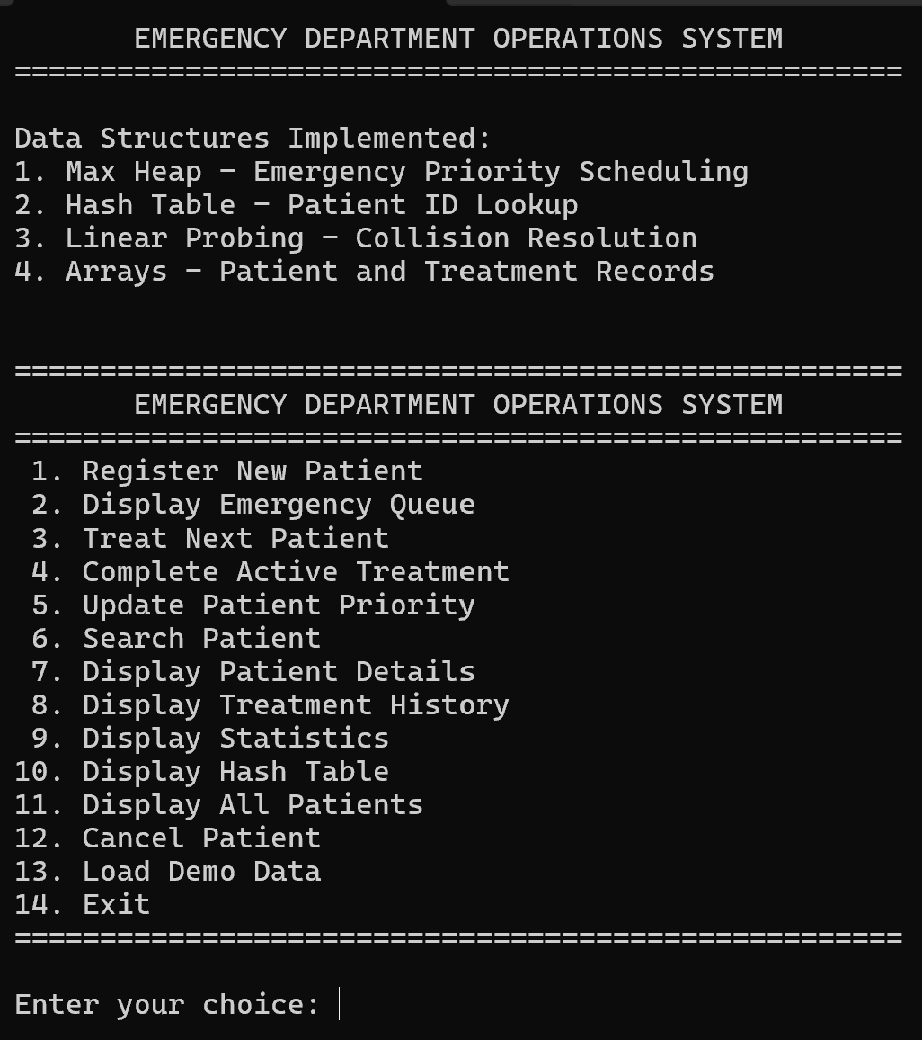

Fig 1 Dashboard

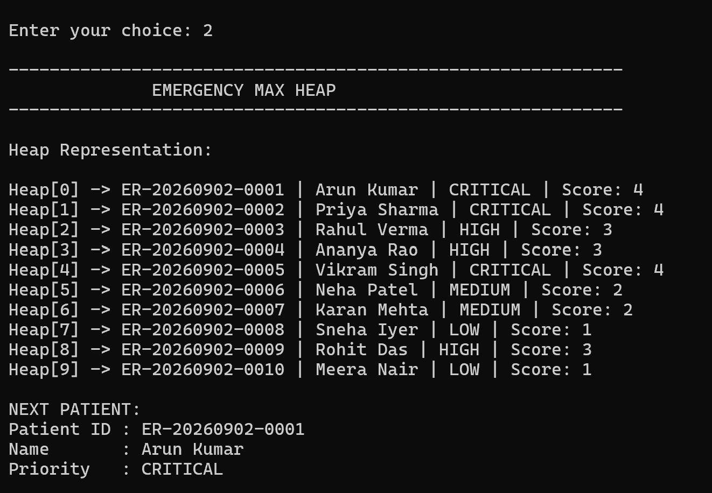
Fig 2 Emergency Max Heap
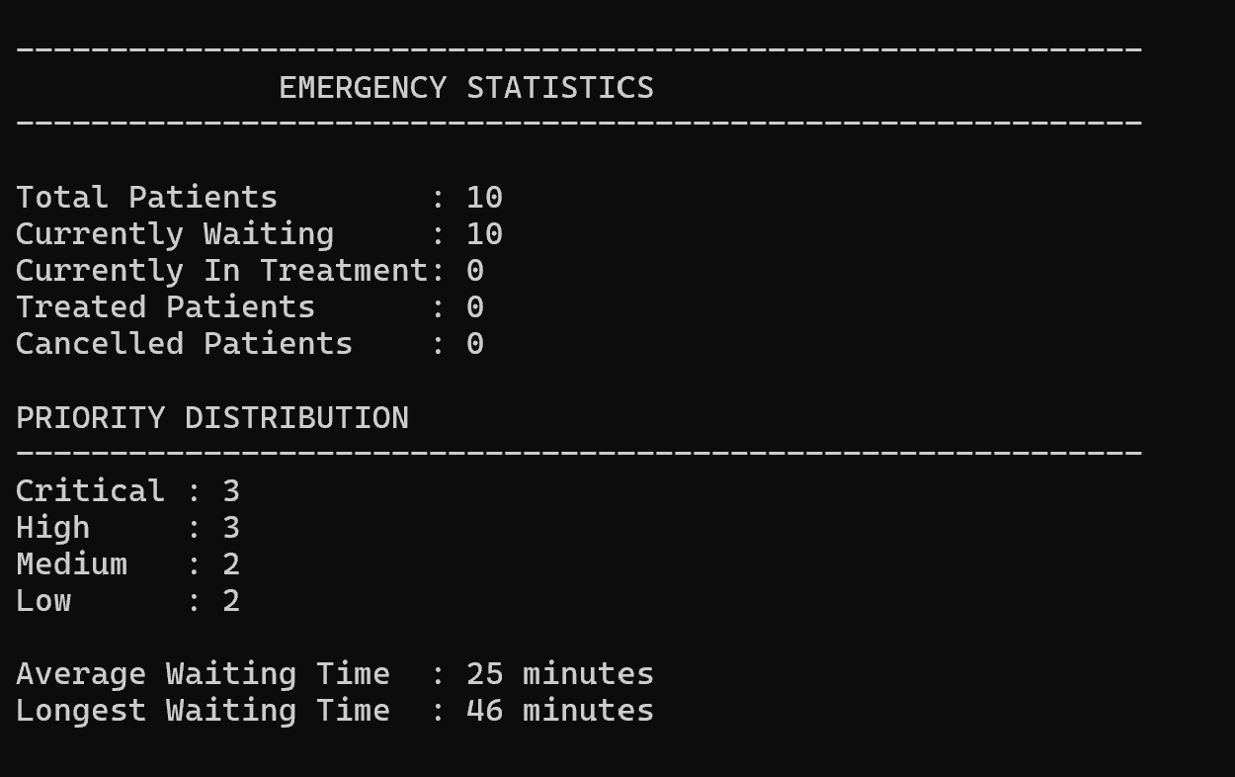

Fig 3 Emergency Statistics

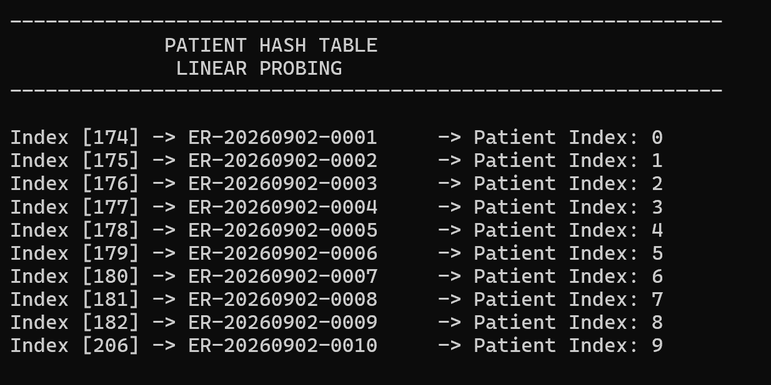

Fig 4 Hash Table

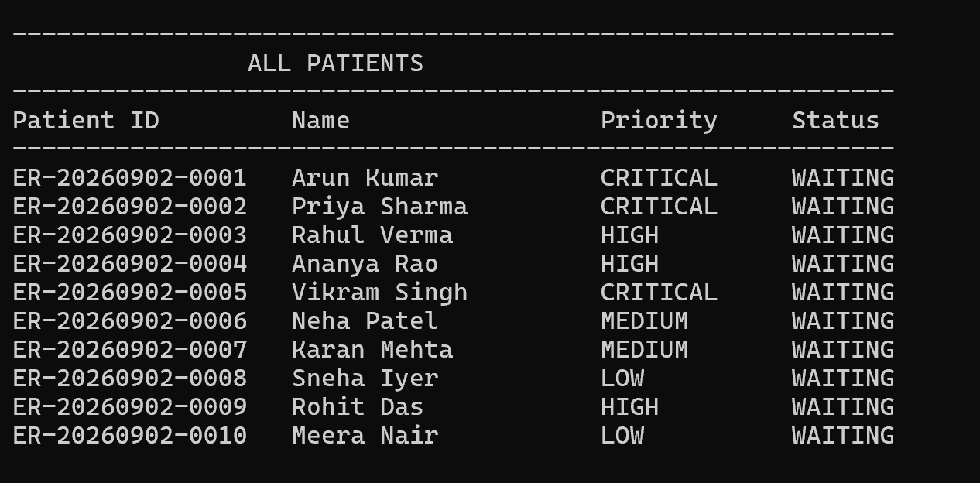

Fig 5 All Patient Details

  - Test Plan & Verification

The system was tested module-by-module and then as an integrated application. The test plan verifies patient registration, priority assignment, heap operations, patient lookup, treatment management, statistics, and report generation.
Requirement | Test Method | Specification / Required Value | Acceptance Criterion | Achieved Value | Status
Patient registration | Enter valid patient details | Patient ID, age and symptoms accepted | Details successfully registered | Insert actual result | Pass/Fail
Priority assignment | Enter different emergency levels | Valid priority assigned | Correct priority displayed | Insert actual result | Pass/Fail
Heap insertion | Register multiple patients | Patient inserted into Max Heap | Heap property maintained | Insert actual result | Pass/Fail
Highest-priority selection | Add patients with different priorities | Highest priority at top | Highest-priority patient selected first | Insert actual result | Pass/Fail
Heap deletion | Complete treatment | Highest-priority patient removed | Waiting queue updated | Insert actual result | Pass/Fail
Patient lookup | Search using Patient ID | Existing ID searched | Correct patient record returned | Insert actual result | Pass/Fail
Waiting-list update | Treat a patient | Treated patient removed | Remaining queue displayed correctly | Insert actual result | Pass/Fail
Waiting-time calculation | Process sample patients | Waiting time calculated | Average waiting time generated | Insert actual result | Pass/Fail
Priority statistics | Process patients with different priorities | Priority counts generated | Counts correspond to processed records | Insert actual result | Pass/Fail
Daily report | Generate report | Report saved as text file | File created successfully | Insert actual result | Pass/Fail
Table 4.3 Test Plan & Verification

Results
The implemented system provides the major functions required for emergency-room priority handling. Patient information can be registered and assigned an emergency priority, after which the patient is placed in the Max Heap priority queue. The heap maintains the treatment order so that the highest-priority patient can be selected first.
The treatment module removes treated patients from the queue and updates the waiting list. The reporting module provides average waiting time, priority-level counts and daily reports that can be saved as text files.

  - Data Analysis & Engineering Judgment

The primary engineering consideration is the efficiency of maintaining the emergency priority order. In a Max Heap, the highest-priority element is maintained at the root, allowing it to be accessed directly. Insertion and deletion require heap reorganization, with a typical time complexity of O(log n), while accessing the highest-priority patient is O(1).
The use of a Hash Table with Linear Probing provides an additional mechanism for locating patient records without requiring the heap itself to perform record searches. This separation of responsibilities improves the organization of the system: the heap manages priority, whereas the hash table manages patient lookup.
The results presented in this project should therefore be interpreted primarily in terms of functional correctness and data-structure efficiency, rather than clinical performance. The system demonstrates the intended computational behaviour, but actual clinical effectiveness would require validation using real hospital data and professional medical evaluation, which are outside the project's scope.

  - Comparison with Existing Solutions & Achievement of Objectives

Objective | Evidence | Achievement
To design an emergency-room patient scheduling system | Complete menu-driven emergency-room scheduling workflow | Fully Achieved
To develop patient registration | Registration of Patient ID, age and symptoms | Fully Achieved
To assign emergency priorities | Emergency-level-based priority assignment | Fully Achieved
To implement Max Heap priority scheduling | Heap insertion, heapify and highest-priority deletion | Fully Achieved
To implement patient lookup | Hash Table with Linear Probing | Fully Achieved
To manage treatment status | Treated patients removed from the queue | Fully Achieved
To calculate waiting-time statistics | Average waiting-time calculation included | Fully Achieved
To count patients by priority | Priority-level statistics included | Fully Achieved
To generate daily reports | Reports generated and saved as text files | Fully Achieved
  - Strengths & Limitations

Strengths
- Uses a Max Heap Priority Queue specifically suited for priority-based scheduling.
- Selects the highest-priority patient first.
- Provides efficient heap insertion and deletion operations.
- Uses a Hash Table with Linear Probing for patient lookup.
- Provides patient registration and priority assignment.
- Supports treatment-status management.
- Calculates waiting-time statistics.
- Provides priority-level counts.
- Generates and saves daily reports.
- Implemented using fundamental C data structures, making the system transparent and suitable for academic demonstration.
Limitations
- The system does not perform actual medical diagnosis or clinical decision-making.
- Priority depends on the emergency level entered by the user.
- The current system is a menu-driven prototype rather than a full hospital information system.
- Data is stored through text-file reporting rather than a database.
- Real-time alerts are not implemented.
- Multiple treatment rooms and resource allocation are not supported.
- No graphical visualization of waiting-time or priority distribution is currently included.
- The system has not been presented as clinically validated.
These limitations are consistent with the future enhancements identified in the project, including database integration, multiple treatment rooms, graphical charts and real-time alerts.

Project Planning, Roles & Budget

You can use the following milestone table in place of a Gantt chart if your college accepts a table:
Phase | Activity | Duration
Phase 1 | Project topic selection and problem identification | Week 1
Phase 2 | Literature review and study of existing approaches | Week 2
Phase 3 | System architecture and data-structure design | Week 3
Phase 4 | Patient registration and priority module development | Week 4
Phase 5 | Max Heap scheduling implementation | Week 5
Phase 6 | Hash Table and patient lookup implementation | Week 6
Phase 7 | Treatment, statistics and reporting implementation | Week 7
Phase 8 | Testing and debugging | Week 8
Phase 9 | Results documentation and PPT preparation | Week 9
Phase 10 | Final report preparation and review | Week 10

Roles / Contribution
Student | Assigned Responsibility | Actual Contribution
D. HOSHEA PAUL (192471019) | System design and implementation | Implementation
NANDHA KRISHNA V (192524012) | Testing, documentation and implementation support | Documentaion

Budget

Since this is a software-based academic project and your PPT does not specify purchased components, the report should not invent hardware or software costs.

Item | Actual Contribution / Use | Estimated Cost (₹) | Actual Cost (₹)
Computer/Laptop | Development and testing | 0* | 0*
C Compiler / Development Environment | Program development | 0* | 0*
Data Structures / C Resources | Implementation reference | 0* | 0*
Text File Storage | Daily report generation | 0* | 0*
Total |  | 0* | 0*

CHAPTER 5

CONCLUSION, FUTURE WORK AND REFLECTION

  - Conclusion

The Emergency Room Priority Handling System Using Heaps was developed to address the problem of scheduling emergency patients according to the urgency of their medical condition rather than simply following their arrival order. A FIFO-based approach may not be suitable for emergency situations because critical patients need to be identified and attended to before patients with lower emergency levels.
The proposed system uses a Max Heap-based Priority Queue to maintain patients according to their assigned emergency priority. Patient details such as Patient ID, age, and symptoms are registered and validated, followed by emergency-level-based priority assignment. The system uses heap insertion, heapify, and deletion operations to maintain the correct priority order and select the highest-priority patient for treatment. A Hash Table with Linear Probing is also used to support patient lookup.
The system is organized into three major modules covering patient registration and priority assignment, heap-based emergency scheduling, and treatment management with reporting and statistics. It also provides waiting-list updates, average waiting-time calculation, priority-level counts, and daily report generation.
The project demonstrates the practical application of fundamental C data structures to a real-world scheduling problem. The Max Heap provides an efficient mechanism for maintaining treatment priority, while the supporting lookup and reporting functions improve the overall organization of the prototype. The project therefore achieves its primary contribution of demonstrating an efficient, structured and transparent approach to emergency-room priority scheduling using fundamental data-structure concepts.
  - Future Work

The current system provides a functional foundation for emergency-room priority scheduling, but several improvements can be incorporated in future versions.
- Dynamic Priority Adjustment: Allow the priority of a patient to be changed when the patient's medical condition changes.
- Multiple Treatment Rooms: Extend the system to manage multiple treatment rooms and allocate patients according to available resources.
- Graphical Visualization: Add graphical representations of waiting time and priority distribution for easier analysis.
- Database Integration: Replace text-file-only history with persistent database storage for improved record management.
- Real-Time Alerts: Introduce alerts for critical or high-priority patients.
- Advanced User Interface: Develop a more user-friendly graphical interface instead of the current menu-driven interface.
- Extended Patient Management: Provide more comprehensive patient-record and treatment-history management.
These enhancements are consistent with the future-enhancement areas identified in the project PPT.

  - Professional Learning & Individual Reflection

New Knowledge Acquired
- Learned the practical implementation of a Max Heap for priority-based scheduling.
- Understood how heapify operations maintain the Max Heap property.
- Learned how priority queues can be applied to real-world scheduling problems.
- Gained knowledge of Hash Tables with Linear Probing for patient lookup.
- Learned how to combine multiple data structures within one C application.
- Understood the importance of testing data-structure operations using different input conditions.
- Learned how software reports can be generated and stored using text-file handling.
Engineering & Professional Skills Developed
- Problem identification and engineering problem formulation.
- Algorithm design and data-structure selection.
- C programming and modular software development.
- Debugging and functional testing.
- Performance and complexity analysis.
- Technical documentation and report preparation.
- Teamwork and task coordination.
- Presentation and communication of technical concepts.
- Understanding of ethical and safety considerations when developing healthcare-related software.

Individual Reflection – NANDHA KRISHNA V
One of the challenging aspects of the project was ensuring that patient information, treatment status and priority ordering remained consistent during different operations. This was handled through structured modules for registration, scheduling, treatment and reporting. A key engineering decision was to use a Hash Table with Linear Probing for patient lookup alongside the Max Heap for priority scheduling, allowing each data structure to perform a specific task efficiently. I independently gained a better understanding of priority queues, heap operations and their practical applications. If the project were repeated, I would focus on improving testing coverage and integrating persistent database storage.

Individual Reflection – D. HOSHEA PAUL
One of the challenging aspects of the project was implementing and maintaining the correct emergency priority order of patients during registration, priority updates, and treatment operations. This was addressed by using a Max Heap to efficiently organize patients according to their emergency priority. I was mainly involved in designing the overall system logic, patient registration process, priority assignment, and heap-based scheduling operations. Through this project, I gained a deeper understanding of priority queues, Max Heap operations, heapify techniques, and their practical application in emergency patient management. If the project were repeated, I would focus on improving the system with more extensive testing, dynamic priority updates, and persistent data storage.

REFERENCES

- N. Gilboy, P. Tanabe, D. Travers, and A. M. Rosenau, Emergency Severity Index (ESI): A Triage Tool for Emergency Department Care, Version 4: Implementation Handbook. Rockville, MD, USA: Agency for Healthcare Research and Quality, 2012.
- Emergency Nurses Association, Emergency Severity Index Handbook, 5th ed. Schaumburg, IL, USA: Emergency Nurses Association, 2023.
- M. J. Morley, M. A. Unwin, C. J. C. Pollard, and P. A. Martin, “Patient flow within UK emergency departments: A systematic review of the use of computer simulation modelling methods,” BMJ Open, vol. 7, no. 5, p. e015007, 2017, doi: 10.1136/bmjopen-2016-015007.
- OpenDSA Project Contributors, “Heaps and Priority Queues,” OpenDSA: Data Structures and Algorithms Modules, Virginia Tech, 2026. [Online].
- ISO/IEC, ISO/IEC 25010:2023: Systems and Software Engineering—Systems and Software Quality Requirements and Evaluation (SQuaRE)—Product Quality Model. Geneva, Switzerland: International Organization for Standardization, 2023.
- ISO/IEC, ISO/IEC 27001:2022: Information Security, Cybersecurity and Privacy Protection—Information Security Management Systems—Requirements. Geneva, Switzerland: International Organization for Standardization, 2022.
- ISO, ISO 14971:2019: Medical Devices—Application of Risk Management to Medical Devices. Geneva, Switzerland: International Organization for Standardization, 2019.
- Princeton University, Department of Computer Science, “Priority Queues,” Algorithms and Data Structures. [Online].
- Emergency Nurses Association, “ENA Updates Emergency Severity Index Resources to Improve Patient Triage,” Mar. 28, 2023. [Online].
- Saveetha School of Engineering, Department of Computer Science and Engineering, “Lecture 18: Heaps and Priority Queues,” course learning material, 2026.
- S. Sahni, Data Structures, Algorithms, and Applications in C++, 2nd ed. New York, NY, USA: McGraw-Hill, 2005.
- B. Stroustrup, Programming: Principles and Practice Using C++, 2nd ed. Boston, MA, USA: Addison-Wesley, 2014.
- Project source code, “Emergency Room Priority Handling System Using Heaps,” C implementation developed for CSA0315 Data Structures, Saveetha School of Engineering, 2026.

APPENDICES

Appendix A – Detailed Calculations
Priority Assignment and Time Complexity Analysis
The Emergency Room Priority Handling System assigns patients an emergency priority based on the severity of their condition.
Emergency Level | Priority Value
Critical | 4
High | 3
Medium | 2
Low | 1
The patient with the highest priority value is given preference for treatment.
Time Complexity Analysis
Operation | Data Structure | Time Complexity
Insert Patient | Max Heap | O(log n)
View Highest Priority Patient | Max Heap | O(1)
Remove Highest Priority Patient | Max Heap | O(log n)
Update Patient Priority | Max Heap | O(log n)
Patient Lookup | Hash Table | O(1) average
Collision Handling | Linear Probing | Depends on load factor
The Max Heap ensures efficient priority scheduling without sorting the complete patient list after every new registration.

Appendix B – Engineering Drawings / Schematics

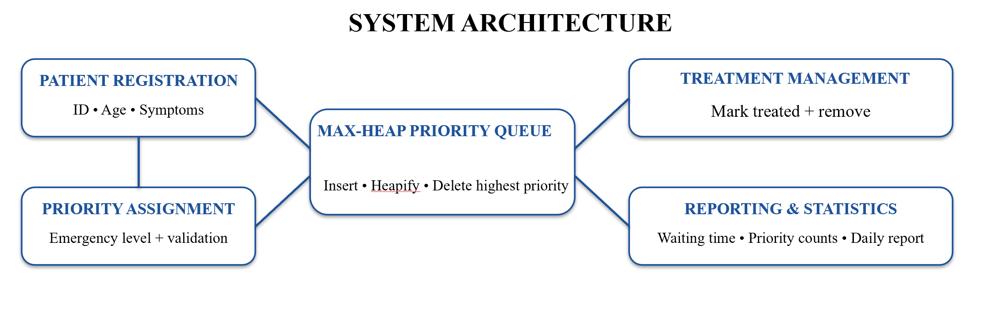

Appendix C – Source Code / Code Repository Information

Source Code Information
The complete project was implemented using the C programming language as a menu-driven application.
The source code implements the following major functionalities:
- Patient registration
- Emergency priority assignment
- Max Heap implementation
- Heap insertion and deletion
- Heapify Up and Heapify Down operations
- Priority-based patient scheduling
- Patient search using a Hash Table
- Linear Probing for collision resolution
- Treatment management
- Patient status updates
- Statistics and reporting
Development Environment
Item | Details
Programming Language | C
Development Environment | Dev-C++
Compiler | GCC
Program Type | Menu-Driven Console Application

Essential Code Excerpt

void heapifyUp(int index)
{
while (index > 0)
{
int parent = (index - 1) / 2;

if (heap[index].priorityScore >
heap[parent].priorityScore)
{
Patient temp = heap[index];
heap[index] = heap[parent];
heap[parent] = temp;

index = parent;
}
else
{
break;
}
}
}

Purpose
The above function restores the Max Heap property after inserting a new patient. If the newly inserted patient has a higher emergency priority than its parent, the patient moves upward in the heap.
Note: The complete source code is maintained separately as part of the project submission.

Appendix D – Datasheets
Not Applicable
This project is a software-based Data Structures and Algorithms implementation and does not involve physical hardware components requiring manufacturer datasheets.

Appendix E – Experimental / Raw Data
Sample Test Data
The following sample patient records were used to test the priority scheduling functionality.
Patient ID | Patient Name | Emergency Level | Priority
P101 | Arun Kumar | Low | 1
P102 | Priya Sharma | Medium | 2
P103 | Rahul Das | High | 3
P104 | Anjali Devi | Critical | 4
Expected Treatment Order
1. Anjali Devi – Critical
2. Rahul Das – High
3. Priya Sharma – Medium
4. Arun Kumar – Low
Observation
The results demonstrate that the system does not follow a simple First-In-First-Out approach. Instead, patients are selected based on their emergency priority.

Appendix F – Ethics / Institutional Approval
Ethical Considerations
This project is an academic software prototype developed for demonstrating the practical application of Data Structures and Algorithms.
- No real patient data was collected or used.
- All patient information used during testing was fictional.
- No clinical decisions were made using the system.
- The application is intended for educational and demonstration purposes only.
Institutional Approval
No separate ethical or institutional approval was required because the project did not involve human participants, clinical trials, medical experimentation, or real patient data.

Appendix G – Project Meeting / Progress Records
Project Progress Summary
Stage | Activity Completed
Problem Identification | Identified emergency patient scheduling as the application domain
System Planning | Defined patient records and emergency priority levels
Design | Designed the Max Heap and Hash Table structure
Implementation | Developed the menu-driven C program
Testing | Tested heap operations and patient priority scheduling
Documentation | Prepared report, presentation, and project documentation

Appendix H – User/Industry Feedback
Academic User Feedback
The project was reviewed from an academic and usability perspective. The feedback indicated that the system successfully demonstrates the practical application of Data Structures in a real-world scenario.
The main positive observations were:
- Clear implementation of priority-based scheduling.
- Effective use of a Max Heap for emergency patient selection.
- Fast patient lookup using a Hash Table.
- Simple menu-driven interface suitable for demonstration and learning.
Suggested Improvements
Potential improvements include:
- Graphical User Interface implementation.
- Persistent database storage.
- Automatic dynamic priority adjustment.
- Support for multiple treatment rooms.

Appendix I – Publications / Patents / Competitions / Product Outcomes
Not Applicable
At the time of submission, the project has not resulted in any publications, patents, competition entries, or commercial product outcomes.
The primary outcome of the project is a functional C-based Emergency Room Priority Handling System demonstrating the application of Max Heap and Hash Table Data Structures.

Appendix J – Individual Contribution Evidence
Student 1: D. Hoshea Paul – Register No. 192471019
Specific Contribution
D. Hoshea Paul contributed primarily to the design and implementation of the core emergency priority scheduling system.
The major contributions include:
- Designing the overall system workflow.
- Implementing patient registration.
- Assigning emergency priority levels.
- Implementing the Max Heap-based priority queue.
- Implementing Heapify Up and Heapify Down operations.
- Implementing priority-based patient selection.
- Testing heap operations and treatment scheduling.
- Contributing to system architecture and implementation documentation.
Individual Reflection
` `One of the challenging aspects of the project was implementing and maintaining the correct emergency priority order of patients during registration, priority updates, and treatment operations. This was addressed by using a Max Heap to efficiently organize patients according to their emergency priority. I was mainly involved in designing the overall system logic, patient registration process, priority assignment, and heap-based scheduling operations. Through this project, I gained a deeper understanding of priority queues, Max Heap operations, heapify techniques, and their practical application in emergency patient management. If the project were repeated, I would focus on improving the system with more extensive testing, dynamic priority updates, and persistent data storage.

Student 2: NANDHA KRISHNA V
Specific Contribution
NANDHA KRISHNA V contributed primarily to patient lookup, treatment management, testing, and supporting system functionality.
The major contributions include:
- Implementing patient lookup functionality.
- Working with the Hash Table and Linear Probing concept.
- Supporting treatment status management.
- Testing patient operations and system functionality.
- Assisting with statistics and reporting.
- Contributing to testing, analysis, and documentation.
Individual Reflection
One of the challenging aspects of the project was ensuring that patient information, treatment status, and priority ordering remained consistent during different operations. This was handled through structured modules for registration, scheduling, treatment, and reporting. A key engineering decision was to use a Hash Table with Linear Probing for patient lookup alongside the Max Heap for priority scheduling, allowing each data structure to perform a specific task efficiently. I independently gained a better understanding of priority queues, heap operations, and their practical applications. If the project were repeated, I would focus on improving testing coverage and integrating persistent database storage.

CAPSTONE PROJECT OUTCOME MAPPING SHEET

To be completed by the department/faculty assessor.

Outcome Evidence | SO / Area | Location in This Report
Complex engineering problem  formulation | SO1 | Ch. 1, Ch. 2
Engineering design under constraints | SO2 | Ch. 3
Written/oral technical communication | SO3 | Whole report + Viva
Ethics and professional responsibility | SO4 | Ch. 3 (3.7)
Teamwork and leadership | SO5 | Ch. 4 (4.8)
Experimentation, analysis, engineering  judgment | SO6 | Ch. 4 (4.3–4.6)
Independent acquisition of new  knowledge | SO7 | Ch. 5 (5.3)
Standards | SO2 | Ch. 3 (3.2)
Sustainability and  societal/environmental impact | SO2/SO4 | Ch. 3 (3.7)
Risk assessment and mitigation | SO2/SO4 | Ch. 3 (3.7)
Security considerations | Relevant SO | Ch. 3 (3.7)
Integrated/system-level engineering | SO1/SO2 | Ch. 3 (3.5)
Project planning and management | SO5 | Ch. 4 (4.8)
Individual contribution | SO1–SO7 | Contribution Statement + Ch. 4  (4.8)

